1st Workshop on Human’s Response to Flowers –
Keynote Speakers

Dr Martin Hůla
Martin Hůla is an evolutionary psychologist and human ethologist focusing on human–plant interactions, particularly phytophilia—the evolutionary origins and expressions of human aesthetic responses to flowers. His research examines how people perceive and evaluate different floral shapes and colours, and whether flower preferences reflect shared, species-typical patterns expressed across infancy, childhood, and adulthood and across cultures. Another line of his research investigates how real and virtual plant-rich environments, such as forests, influence human well-being.
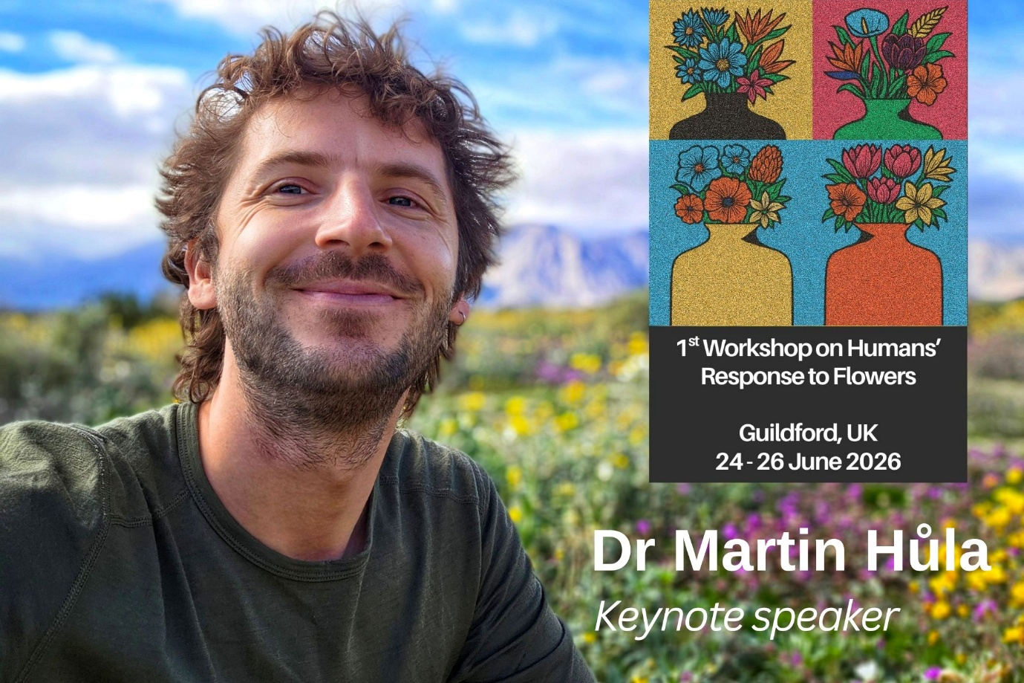
ORCID: https://orcid.org/0000-0003-2796-1226
Website: https://psych.ucsb.edu/people/visitors/martin-hula

Dr Melinda J Knuth
Dr. Knuth’s research priorities are on business management and consumer behavior research. Historically, Dr. Knuth has evaluated trade flows of horticulture products in the United States, estimated the economic impact of the North Carolina and United States green industries and national compost industry, assessed the benefits plants provide to human health, and estimated consumer acceptance of retail garden center messaging. She currently is an Assistant Professor in Horticultural Science at North Carolina State University. Dr. Knuth teaches Greenhouse Management, Floriculture Production, Horticulture Business Development, and Horticulture Marketing. Dr. Knuth received her PhD from Texas A&M University in Horticultural Science with a certificate in Applied Statistics. From there, she was a postdoctoral research associate at University of Florida in the Food & Resource Economics Department. She currently serves as the International Society for Horticulture Science Division Chair of Horticulture for Development and as a GenNext Lead with AmericanHort. Her poster ‘Exploring Artificial Intelligence Literacy Amount Two-Year Horticulture Students’ was voted Outstanding Poster at the 2025 NCSU Conference of Faculty Excellence. Dr. Knuth received the 2025-26 Goodnight Early Career Faculty Award at NCSU and GPN Magazine’s 40 under 40 award in 2021.
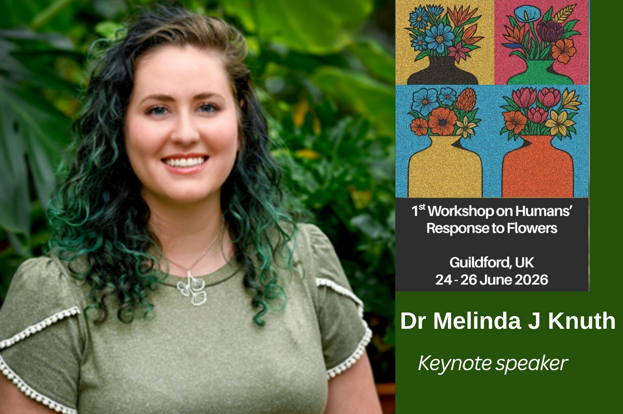
ORCID: 0000-0001-5406-1595
Website: https://cognitivebehaviorallab.cals.ncsu.edu/
Professor Sylvie Baudino
Sylvie Baudino is an emeritus professor at the University of Saint-Etienne (France) and researcher at the Laboratory of Plant Biotechnology applied to aromatic and medicinal plants (LBVpam). She study the production of scent compounds in plants, in particular the biosynthesis pathways of terpenes. She want to know why some plants are heavily fragrant while others are not. My favorite plant model is the rose. She discovered a new pathway for terpene biosynthesis in this plant (Magnard et al. Science 2015 DOI: 10.1126/science.aab0696).
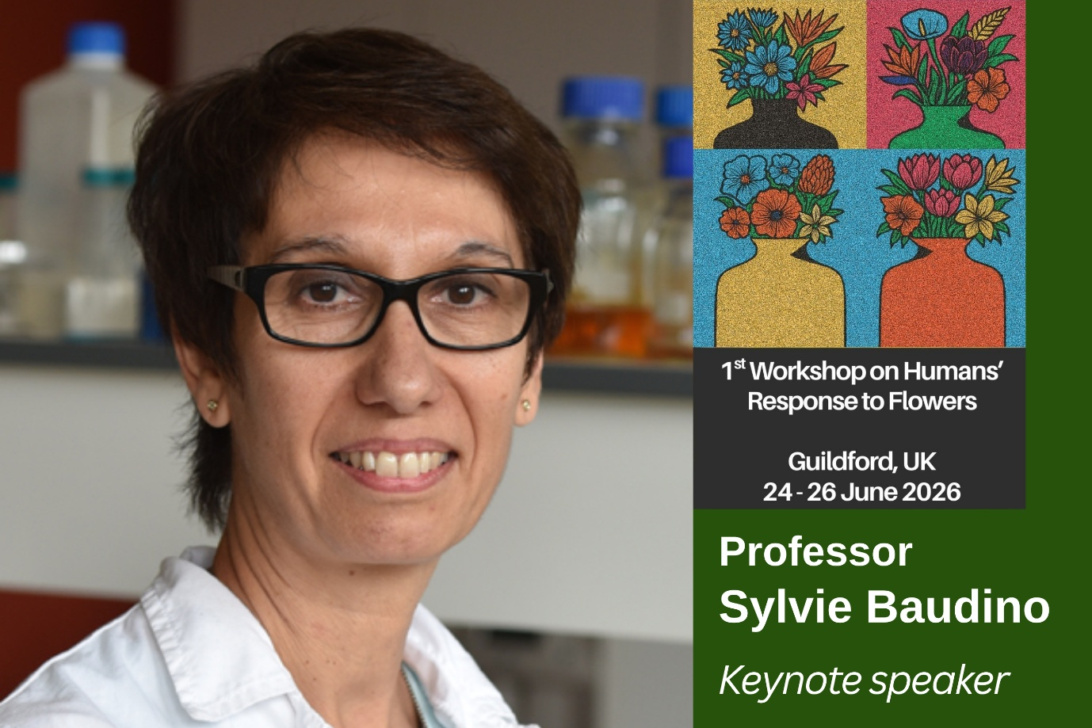
ORCID: 0000-0002-3367-172X
Lab website: https://lbvpam.univ-st-etienne.fr/en/index.html
Lab linkedin: https://www.linkedin.com/company/lbvpam/

Dr Jill Timms
Jill is a sociologist of work and the environment. She is an Associate Professor in Sociology at the University of Surrey, a founding Fellow in the Institute for Sustainability and Co-Lead of the Sustainable Flowers Research Project. Jill has been researching the flower industry for over two decades, since her PhD from London School of Economics. Her interests focus particularly on the role of collaboration; responsibilities to workers and the planet in complex global supply chains; the rise of private standards and certification schemes; and the role of different groups, such as consultants, campaigners, governments and consumers, in changing policy and practice towards net-zero. Jill works with key industry stakeholders to improve sustainable practice in horticulture, has been funded by the British Academy/Leverhulme Trust, ESRC, AIPH, IDH, DEFRA and UKIR. Jill is an Academic Advisor to the Sustainable Floristry Network and on the national committee of Sustainable Church Flowers (SCF) movement, with the SCF motion recently voted for by the Church of England for its use of sustainable flowers. Other recent work includes research with David Bek and the Flower Growing Collective to promote routes to market for seasonal flower growers through a national system of Hubs organised on a cooperative basis, and the piloting of a new agroecological standard for flower growers. Jill is also currently Editor in Chief of the journal Sociology, and has regularly delivered presentations at events for the British Florist Association, Flowers from the Farm, the Fairtrade Foundation, the Big Green Week and other public engagement events. She is Co-Organiser of our Human Response to Flowers Workshop too!
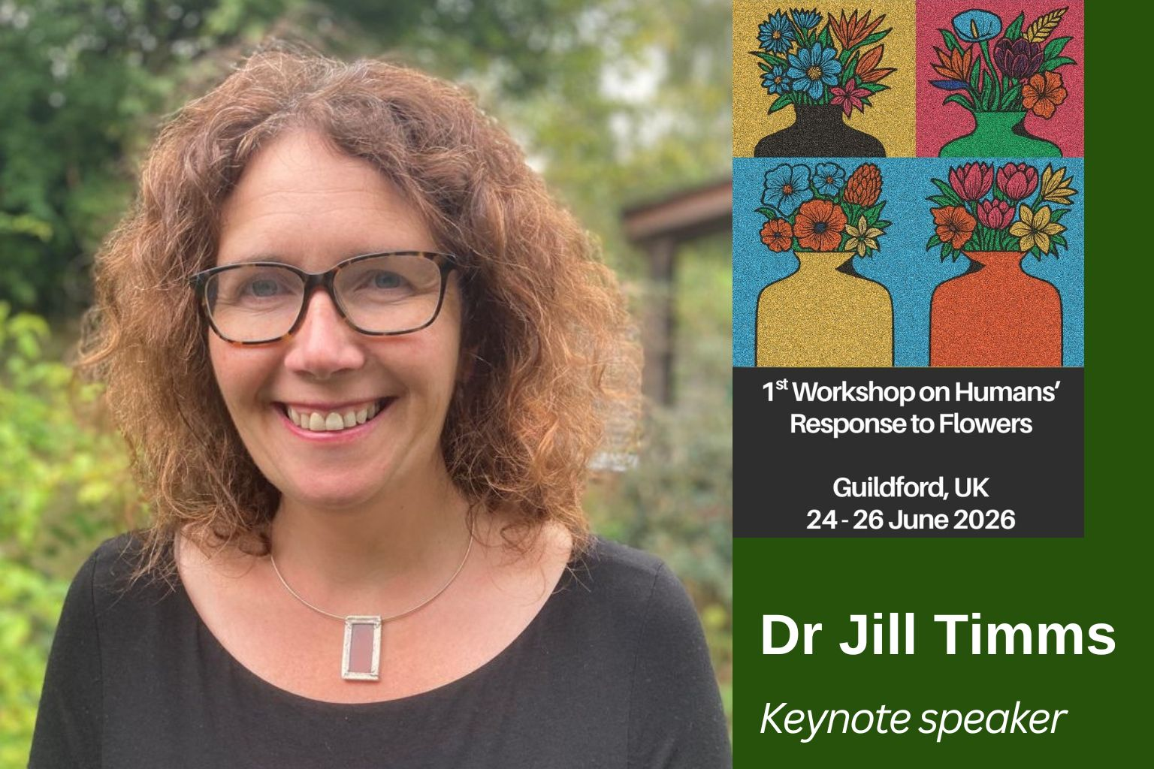
Orchid: 0000-0002-4155-6481
Webpage: https://www.surrey.ac.uk/people/jill-timms
LinkedIn: https://www.linkedin.com/in/jill-timms-sociologist/
Project Website: https://sustainableflowersresearch.org/

